The Right Choice – by Michaela Strange – 4 minutes
Haya-Lea Detinko - Centropa movie – 17 minutes

Acknowledgement: I used resources from the Centropa website including some of Ursula Reinhart Doring’s lesson plan from the teachers’ section. Because her lesson was designed for ESL kids, I adapted it for English speakers and added my own stuff too.

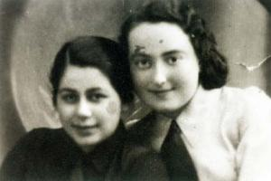Haya-Lea (right) and friend

Haya Lea Detinko
Haya Lea Kats in her Hashomer Hatzair group in 1935.
Haya-Lea was born in the Polish town of Rovno, where she grew up in a traditional Jewish family, joined a Zionist youth club and looked forward to emigrating to Palestine, just like her sister. But the Soviets took
eastern Poland in September 1939 and Haya-Lea's membership in Hashomer Hatzair earned her a ten year sentence of hard labor in Siberia. The rest of her family remained behind, not knowing that the Nazis would overrun the town soon after Haya-Lea's deportation to the east.

Key Terms
Russian Revolution  Zionism  Aliya  Kibbutz  Hashomer Hatzair  Partition of Poland - Molotov-Ribbentrop Pact (August 23, 1939) | Einsatzgruppen  Nazi Invasion of Russia - 1941  Gulag  Perestroika  penal camp  Marshal Pilsudski  Stalin

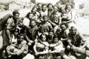 Hashomer Hatzair Group

Class Discussion Questions: Haya‐Lea Detinko – For English speakers we simply had a discussion whereas Ursula used this as a worksheet.
1. Why aren’t there any pictures of Haya‐Lea`s childhood?
2. What was the town of Rovno like in the 1920s?
3. Why did Haya` father become a businessman?
4. What are Tarbut schools famous for?
5. Why did Haya’s family members and friends leave Poland?
6. What is said about Marshal Pilsudski?
7. Sum up what you learn about the Hashomer Hatzair movement.
8. What happened in the year 1939 in Poland? List the consequences for the Poles.
9. Why did Haya’s mother faint on the 5th of June, 1941?
10 Why does the box with winter clothes sent to Haya make her very afraid?
11. When did the war start for the Soviets and who was fighting?
12. What was she accused of?
13. What did daily life look like for a prisoner?
14. What happened to Haya’s family members?
15. How did Haya meet her future husband? What do you learn about his past?
16. What is Haya finally allowed to do in the year 1961?
17. What does Perestroika mean to Haya?
18. Explain the role and meaning of “Hesed Center”!

1 Find a Map and answer these questions:
Find a larger map of Europe between the wars and show the partition of Poland in 1939.Speculate on potential consequences this treaty had on the people who lived in this area. Sum up how the pact had a huge impact on Haya-Lea`s life. Discuss whether the term “non-aggression pact” is appropriate or rather misleading.

2 How does your youth compare to Haya Lea’s
Your life – including family, friends, home town, religion.  Consider these ideas: hopes and dreams war, peace, happiness, despair, freedom | Haya Lea’s life – including family, friends, home town, religion.  Consider these ideas: hopes and dreams war, peace, happiness, despair, freedom
 | Irv Grodessoff’s life – from The Right Choice by Michaela Strange

2 Remember a significant change in your life. Get ino pairs and ask them to tell each other about this life change and the impact it had. Now talk about the big changes in Haya Lea’s and Irv’s lives.

3 Write a short paragraph about your thoughts about the 2 movies and how this relates to our history and to your lives.

4 What connections can you make between the history we have studied so far – The Jews of Eastern Europe Unit and the unit on Early Zionism:
History we have studied | History you connected with in the movies we saw

Write a poem about Haya Lea Detinko using the link to the I Am From format.
RESOURCES
Molotov-Ribbentrop Pact (August 23, 1939)
The beginning of World War II puts an end to the Second Polish Republic. On the 1st of September 1939 Poland is invaded by Nazi Germany. As stipulated by the secret Molotov‐Ribbentrop Pact, Soviet forces invade Poland two weeks later and occupy East‐Poland. The Polish government does not surrender but goes into exile. Invading German troops approach Bydgoszcz. Poland, September 18, 1939.
On August 23, 1939, Hitler and Stalin signed a non-aggression pact, called the Molotov-
Ribbentrop Treaty. Secret protocols of the treaty defined the territorial spheres of influence Germany and Russia would have after a successful invasion of Poland. Hitler had been creating justifications and laying plans for such an invasion since April. According to the agreement, Russia would have control over Latvia, Estonia, and Finland, while Germany would gain control
over Lithuania and Danzig. Poland would be partitioned into three major areas. The Warthland area, bordering Germany would be annexed outright to the German Reich, and all non-German inhabitants expelled to the east. More than 77,000 square miles of eastern Polish lands, with a population of over thirteen million would become Russian territory. The central area would become a German protectorate, named the General Government, governed by a German civil authority.

To read more about the secret protocol go to: Jewish Virtual Library

German Invasion of the Soviet Union
The 1941 German invasion of the Soviet Union was particularly horrific for Soviet Jewry. About 2.5 million Jews were annihilated, often by collaborators among the native populations in the occupied territories who aided the Germans in killing Jews.
Jews were the most dispersed nationality in the Soviet Union. In 1989 a majority of the 1.4 million Jews in the Soviet Union lived in the three Slavic republics. Approximately 536,000 lived in the Russian Republic, 486,000 in the Ukrainian Republic, and 112,000 in the Belorussian Republic. Soviet Jews were overwhelmingly urban. In 1979 over 98 percent of all Jews in the Soviet Union lived in urban areas. Four cities in particular--Moscow, Leningrad, Kiev, and Odessa--had large concentrations of Jews. Along with being the most urbanized nationality, in the 1970s Jews also ranked first among all nationalities in educational level and in numbers of scientific workers per thousand. Between 1959 and 1989, the Jewish population in the Soviet Union declined by about 900,000. The decline was attributed to several factors--low birth rate, intermarriage, concealment of Jewish identity, and emigration.

The Gulag (Forced Labor Camp)
An essential element of Stalin's Terror Regime was the Gulag-system. "GULAG" is an acronym for the Soviet bureaucratic institution, (Glavnoe Upravlenie ispravitel'no-trudovykh LAGerei) ("Main Administration of Corrective Labor Camps") that operated this system of forced labor camps. The system was first established in 1919 under the Cheka, but it was not until the early 1930s that the camp population reached significant numbers. By 1934 the Gulag, then under the Cheka's successor organization the NKVD, had several million inmates. Prisoners included murderers, thieves, and other common criminals, along with political and religious dissenters.
The Gulag-camps were located mainly in remote regions of Siberia and the Far North. They made significant contributions to the Soviet economy. Gulag prisoners constructed the White Sea-Baltic Canal, the Moscow-Volga Canal, the Baikal-Amur railroad line, numerous hydroelectric stations, strategic roads and industrial enterprises in remote regions.
The Gulag Archipelago is a famous book by Alexander Solzhenitsyn about the Gulag-System. The book, first published in 1973, is a massive narrative relying on eyewitness testimony and primary research material, as well as Solzhenitsyn's own experiences as a prisoner in a Gulag labor camp. While the Gulag was radically reduced in size following Stalin's death in 1953, forced labor camps and political prisoners continued to exist in the Soviet Union right up to the Gorbachev era. (Excerpt - Gulag)

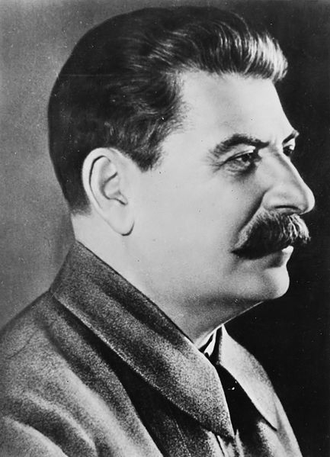 Stalin
Extra activity: Gulag
Go to Gulag and prepare a short presentation (e.g. power point) on the Gulag. The presentation should include pictures, maps, testimony from witnesses, etc. How did the Gulag differ from German concentration camps?

